Public Sessions: Hidden URL

How to hide a session from the shopping cart and still allow registration

  - Enrole - Entrinsik

Provided by Information Technology Services
Created July, 2022
Contents
Purpose 2
Confirm Course and Session are Setup Correctly 2
Flush the Cache 3
Obtain Hidden URL from Shopping Cart 4

Purpose
Allow registrations for certain customers, without the Public Session displaying on the Shopping Cart to the public.

IMPORTANT NOTE: Hidden URLs apply to Public Sessions only. Public Sessions do not have Self-Registration URLs and Codes. Only Custom Training Sessions utilize the ‘Self-Registration Code’ and ‘Self-Registration URL’ User Defined Fields (UDFs), which are automatically generated upon the creation of a Custom Training Session. These UDFs will be blank/empty for Public Sessions.

Confirm Course and Session are Setup Correctly
- Create the Course and Public Session as usual
- The Course will need to have the following defined:
  - Status is ‘Active’
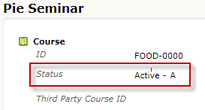
  - Categories are assigned
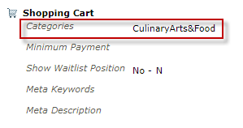
NOTE: The Course and Sessions will not appear on the Shopping Cart if the Course does not have a Category assigned.
- The Session will need to have the following defined:
  - Status is ‘Open’
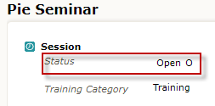
  - Show on Web is set to ‘Yes’
  - Show From and Show To dates are either filled in to set desired limits or left blank to indicate all dates
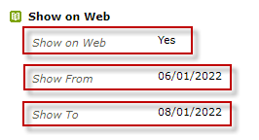
  - Pricing must be added and Display set to ‘Yes’
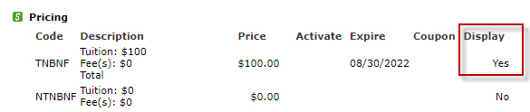
NOTE: Customers can not add the session to their cart and check out if no pricing has been defined and is not set to display ‘Yes’.
  - Schedule must be setup as well
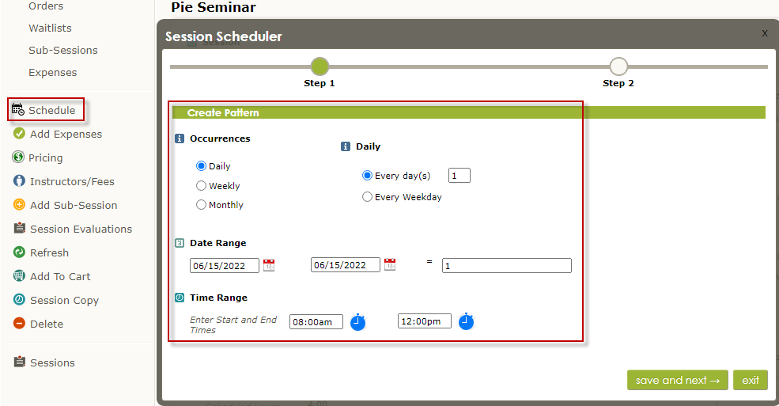

Flush the Cache
Once you have confirmed the Course and Session are setup correctly, the cache will need to be flushed before the Course and Session(s) will appear on the Shopping Cart website.
- Submit a Ticket to tdxhelpdesk@tulsatech.edu requesting to “Flush the Cache”
- The Enterprise Applications team will process the ticket by:
  - Logging into the Admin Portal
  - Select ‘Cart’, then select ‘Caches’
  - Click Flush All Caches
  - Logout of the Admin Portal
NOTE: The Enterprise Applications team will perform these steps again, AFTER the Hidden URL has been obtained.

Obtain Hidden URL from Shopping Cart
Once the cache has been flushed for the Session to appear on the Shopping Cart, the hidden URL can now be obtained.
- Navigate to the Shopping Cart website: https://www.enrole.com/tulsatech/jsp/
- Locate the Session by utilizing the left navigation pane to select the Category you assigned to the Course
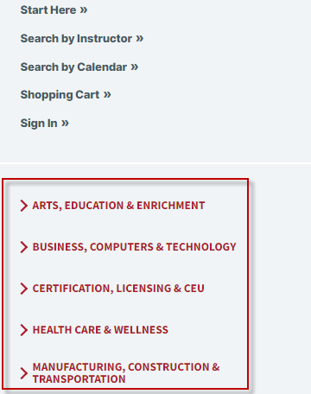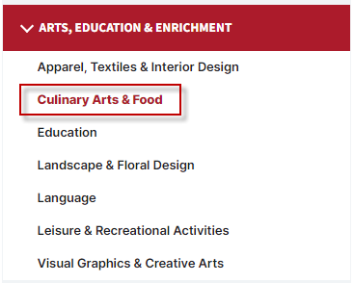
- Click on the Session link once you have located it
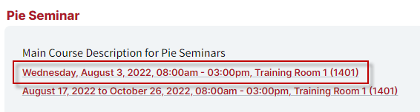
- Click in the URL (web address) box at the top of the web browser to highlight the URL, then COPY (CRTL +C) the URL
- Paste the URL to either the ‘Self-Registration URL’ UDF on the Session or into an email you will send customers
- Remove the Categories for the Course
NOTE: When Courses do not have Categories assigned, the Session(s) will not display on the Shopping Cart.
- Submit a Ticket to tdxhelpdesk@tulsatech.edu requesting to “Flush the Cache” again
NOTE: This step will remove the Session(s) from appearing on the Shopping Cart so they will not be visible to the public.

IMPORTANT NOTE: The Hidden URL will not work until the ‘Show From’ date has arrived/occurs. For example: if the ‘Show From’ date is set to 07/30/2022, the Hidden URL will prompt an error on 07/15/2022 because the defined Show From date has not yet arrived/occurred. Simply change the ‘Show From’ date if you need customers to register earlier than previously defined.

